Xamarin Saturday August 2019 - Xamarin 101 Workshop

Exercise 2 – Creating Monkey APP

# 1 - Add Xamarin.FFImageLoading.Forms to all projects

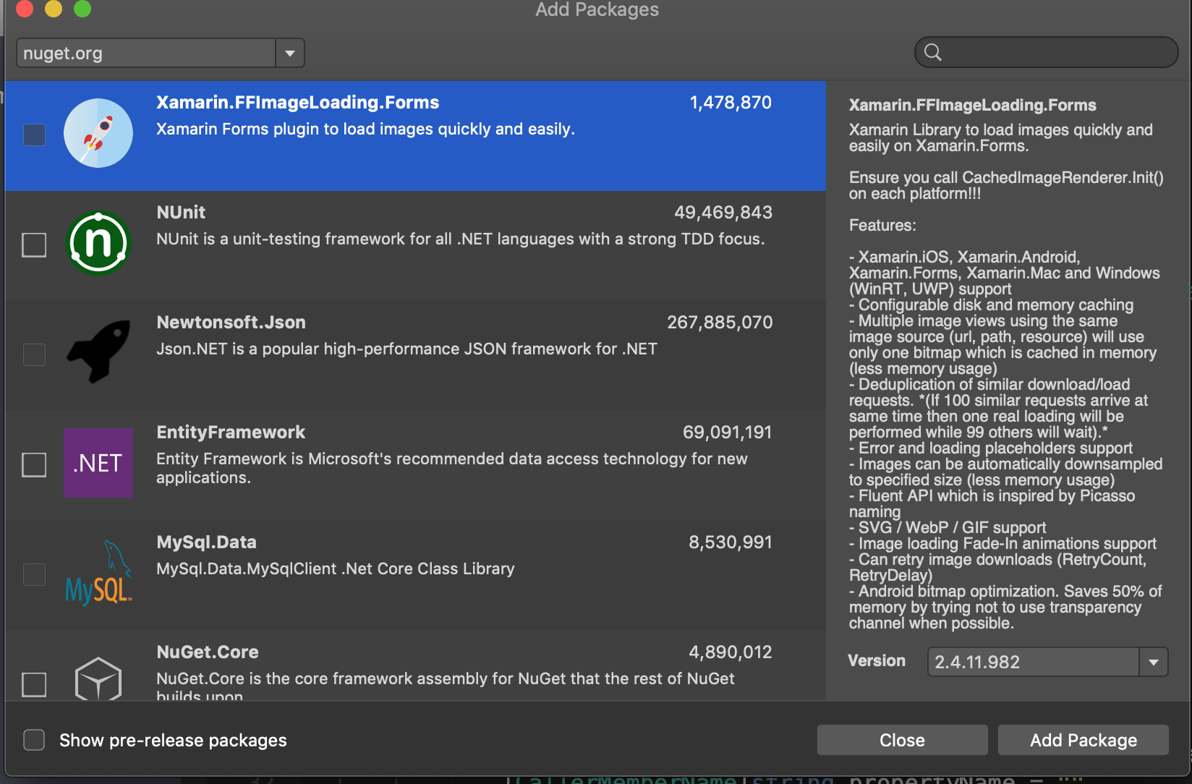

# 2 – Add URL property to the Item Class

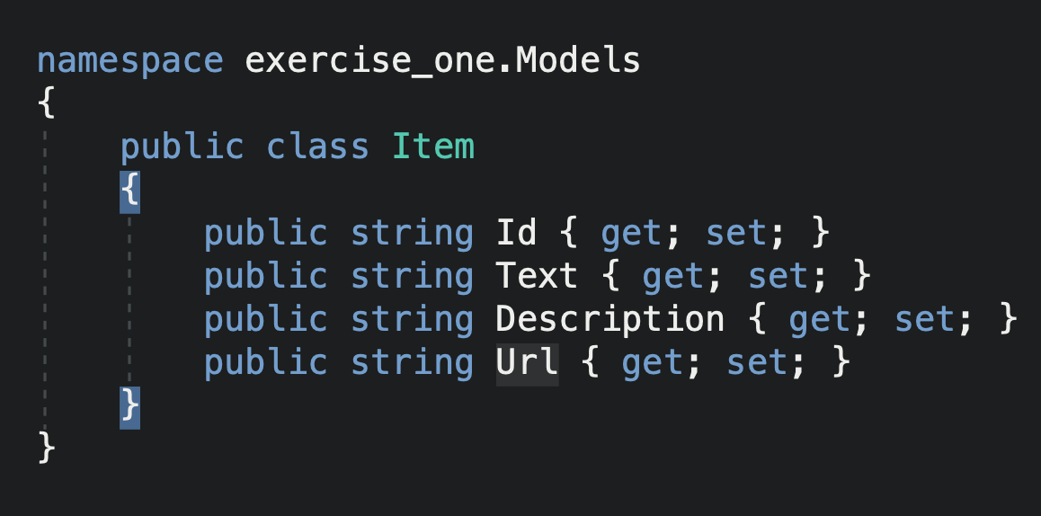

# 3 – Edit MockDataStore.cs where the list is populated:

new Item { Id = Guid.NewGuid().ToString(), Text = "First item", Description="This is an item description.", Url = "<http://upload.wikimedia.org/wikipedia/commons/thumb/9/96/Portrait_Of_A_Baboon.jpg/314px-Portrait_Of_A_Baboon.jpg>"},

new Item { Id = Guid.NewGuid().ToString(), Text = "Second item", Description="This is an item description.", Url = "<http://upload.wikimedia.org/wikipedia/commons/thumb/4/40/Capuchin_Costa_Rica.jpg/200px-Capuchin_Costa_Rica.jpg>"},

new Item { Id = Guid.NewGuid().ToString(), Text = "Third item", Description="This is an item description.", Url = "<http://upload.wikimedia.org/wikipedia/commons/thumb/8/83/BlueMonkey.jpg/220px-BlueMonkey.jpg>"},

new Item { Id = Guid.NewGuid().ToString(), Text = "Fourth item", Description="This is an item description.", Url = "<http://upload.wikimedia.org/wikipedia/commons/thumb/2/20/Saimiri_sciureus-1_Luc_Viatour.jpg/220px-Saimiri_sciureus-1_Luc_Viatour.jpg>" },

new Item { Id = Guid.NewGuid().ToString(), Text = "Fifth item", Description="This is an item description.", Url = "<http://upload.wikimedia.org/wikipedia/commons/thumb/8/87/Golden_lion_tamarin_portrait3.jpg/220px-Golden_lion_tamarin_portrait3.jpg>" },

new Item { Id = Guid.NewGuid().ToString(), Text = "Sixth item", Description="This is an item description.", Url = "http://upload.wikimedia.org/wikipedia/commons/thumb/0/0d/Alouatta_guariba.jpg/200px-Alouatta_guariba.jpg" }

# 4 – Open ItemsPage.xaml, clear ItemSource with arrays

5 – Import FFImageLoader to Page  
xmlns:ffimageloading="clr-namespace:FFImageLoading.Forms;assembly=FFImageLoading.Forms"

6 – Add to iOS AppDelegate  
FFImageLoading.Forms.Platform.CachedImageRenderer.Init();

Add to Android MainActivity.cs

FFImageLoading.Forms.Platform.CachedImageRenderer.Init(true);

# 7– Add ffimage loader to listview and Change the Source to Bind to Item.URL

<Grid>

<Grid.ColumnDefinitions>

<ColumnDefinition Width="100"/>

<ColumnDefinition/>

</Grid.ColumnDefinitions>

<Grid.RowDefinitions>

<RowDefinition/>

<RowDefinition/>

</Grid.RowDefinitions>

<ffimageloading:CachedImage

Grid.Row="0"

Grid.Column="0"

Grid.RowSpan="2"

Source="{Binding Url}"/>

<Label Text="{Binding Text}"

Grid.Row="0"

Grid.Column="1"

LineBreakMode="NoWrap"

Style="{DynamicResource ListItemTextStyle}"

FontSize="16" />

<Label Text="{Binding Description}"

Grid.Row="1"

Grid.Column="1"

LineBreakMode="NoWrap"

Style="{DynamicResource ListItemDetailTextStyle}"

FontSize="13" />

</Grid>

# 8 – Change from a list to a CollectionView and make the list horizontal

# 9 - Extra Challenges

Change the stack layout from the ItemDetailPage.xaml

* Grid : <https://docs.microsoft.com/en-us/xamarin/xamarin-forms/user-interface/layouts/grid>
* FlexLayout: <https://docs.microsoft.com/en-us/xamarin/xamarin-forms/user-interface/layouts/flex-layout>